Bio’s PPNST Conference 29/7/23
Tiana Hippolite Pasifika Womens Alliance Inc.
The Pasifika Women’s Alliance Inc. (PWA) is a non-political, non-sectarian, not-for-profit women’s alliance. The alliance seeks to build and strengthen a Queensland sisterhood of Pacific Islander women and to raise awareness of members as to their rights and responsibilities as citizens and encourages their participation in all aspects of community life.
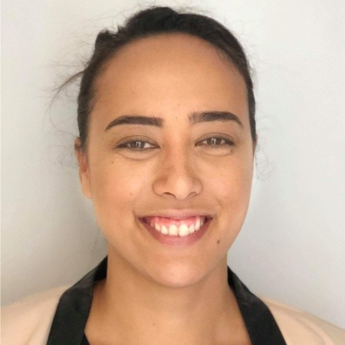

Shinako Oyakama
Okinawan activist fights for rights of indigenous Ryukyuans at U.N. forum
Shinako Oyakawa (Okinawa) is a native Okinawan mother, activist, writer, co-director of the Association of Comprehensive Studies for Independence of the Lew Chewans (ACSILs) and part time lecturer of Okinawa University. She also runs after school kids programs in Naha. Shinako specializes in language revitalization, de-militarization and de-colonization of the Ryukyu islands. Shinako has attended the UN Permanent Forum on Indigenous Issues (UNPFII) and Expert Mechanism on the Rights of Indigenous Peoples (EMRIP) to report on the colonized situation of the Ryukyu islands.
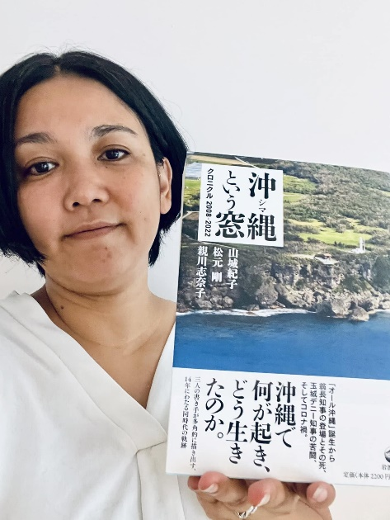

Monaeka Flores
https://independentguahan.org/who-are-we/
Independent Guåhan empowers the Chamoru people to reclaim our sovereignty as a nation. Inspired by the strength of our ancestors and with love for future generations, we educate and unify all who call our island home to build a sustainable and prosperous independent future.
Monaeka Flores is a queer CHamoru activist, artist and daughter of Guåhan. She is a member of several community organizations that focus on CHamoru self-determination, environmental justice and the protection of sacred sites.
https://youtu.be/7AhLkzMPLyQ
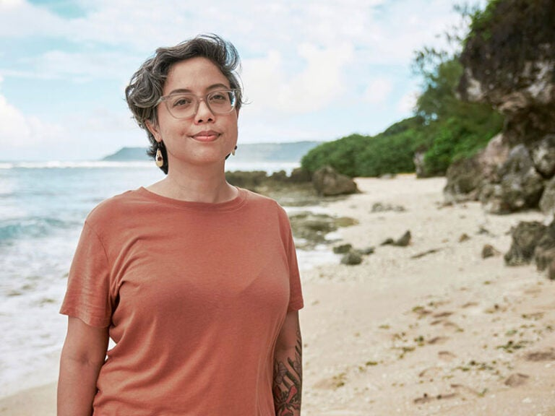

Anne Pakoa: Vanuatu’s Human Rights defender
Anne Pakoa is a household name in the Pacific region’s Civil Society world. As Secretary of the Vanuatu Human Rights Coalition, she is both vice-chair of the African-Caribbean-Pacific (ACP) Non-State Actors Network Steering group as well as part of the Civil Society Forum. Climate justice, civil sohttps://concordeurope.org/2019/04/24/talking-with-anne-pakoa/ciety participation, and women’s rights are at the core of Ms Pakoa’s daily business.
https://concordeurope.org/2019/04/24/talking-with-anne-pakoa/

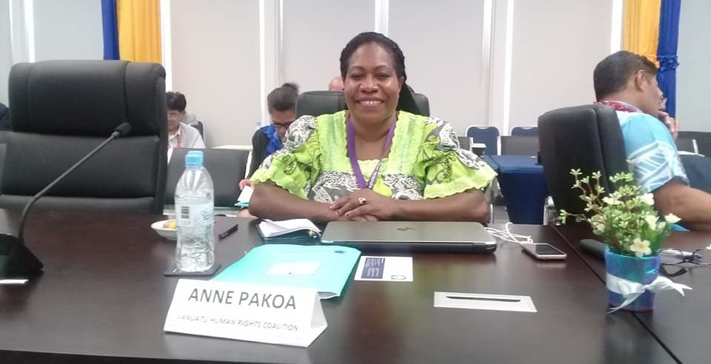

Dr Arama Rata (Ngāruahine, Taranaki, Ngāti Maniapoto) is Senior Research Fellow at the National Institute of Demographic and Economic Analysis, University of Waikato. Her background is in Psychology and Statistics and current research foci include Māori-migrant relationships, iwi connectedness, and Māori wellbeing.
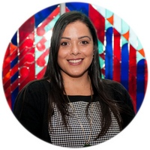
Richard Tanter
Assoc Professor Richard Tanter has worked on security and environmental issues as a teacher, researcher, policy analyst, and advocate in Australia, the United States, Japan, Korea and Indonesia since the 1970s. He is currently Senior Research Associate at the Nautilus Institute for Security and Sustainability, and Professorial Fellow (Honorary) in the School of Social and Political Sciences at the University of Melbourne. At Melbourne University he teaches on nuclear weapons, and on East and Southeast Asian issues.
Richard has been researching a range of technical and strategic issues related to US and Australian intelligence and military facilities in Australia, including the 2012 study The “Joint Facilities” revisited – Desmond Ball, democratic debate on security, and the human interest, and he is currently completing a study of Pine Gap, North West Cape, and Geraldton, and other major facilities in Australia.
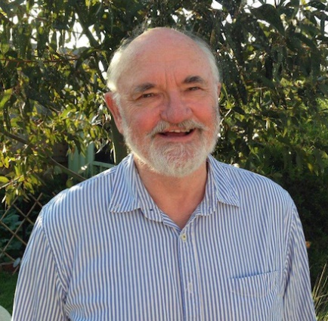

Michelle Maloney
Dr Michelle Maloney is Co-Founder and National Convenor of the Australian Earth Laws Alliance (AELA), and is a Director of Future Dreaming and the New Economy Network Australia. Michelle began life as a lawyer and now works across a range of disciplines to advocate for Earth-centred governance and systems change.
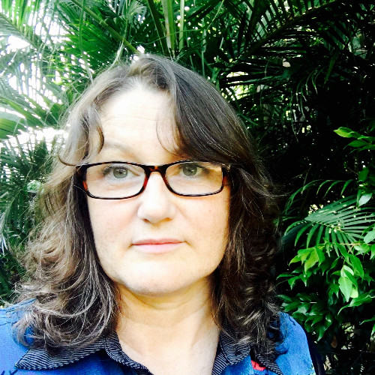

Dimity Hawkins AM
Dimity has over three decades of experience in the civil society sector working as an advocate on issues of nuclear disarmament and broader social, environmental and human rights activism. She was a co-founder of the International Campaign to Abolish Nuclear weapons (ICAN). Dimity is completing her PhD through Swinburne University in Melbourne focussed on nuclear weapons testing in the Pacific. She is also a co-coordinator of the Nuclear Truth Project. Dimity was made a Member of the Order of Australia (AM) in the 2019 Queens Birthday Honours for “significant service to the global community as an advocate for nuclear non-proliferation and disarmament.”

David Shoebridge is an Australian politician and former barrister. He is a member of the Australian Greens and was elected to the Senate as the party's lead candidate in New South Wales at the 2022 federal election, to a term beginning on 1 July 2022. He previously served in the New South Wales Legislative Council from 2010 to 2022 and on the Woollahra Municipal Council from 2004 to 2012.
Senator Shoebridge tabled the Independent and Peaceful Australia Network Peoples Inquiry Report Charting our Own Course- Next Steps towards and Independent Peaceful Australia in the Federal Senate in November 2022.
